Practical 7
Part A
1) | Form validator: define @NotBlank and @MaxLength(int) for fields and annotate a  SignupForm. Write a checker that uses reflection to read each field’s annotations and  returns the list of validation errors for a given object.
 | FormDemo.java
Code | import java.lang.annotation.*;  import java.lang.reflect.Field;  import java.util.ArrayList;  @Retention(RetentionPolicy.RUNTIME)  @Target(ElementType.FIELD)  @interface NotBlank {}  @Retention(RetentionPolicy.RUNTIME)  @Target(ElementType.FIELD)  @interface MaxLength { int value(); }  class SignupForm {  @NotBlank @MaxLength(10) String name;  @NotBlank String email;  SignupForm(String name, String email) { this.name = name; this.email = email; }  }  public class FormDemo {  static ArrayList<String> check(Object obj) throws IllegalAccessException {  ArrayList<String> errors = new ArrayList<>();  for (Field f : obj.getClass().getDeclaredFields()) {  f.setAccessible(true);  Object value = f.get(obj);  if (f.isAnnotationPresent(NotBlank.class)  && (value == null || value.toString().isBlank())) {  errors.add(f.getName() + " must not be blank");  }  MaxLength rule = f.getAnnotation(MaxLength.class);  if (rule != null && value != null && value.toString().length() > rule.value()) {  errors.add(f.getName() + " is too long");  }  }  return errors;  }  public static void main(String[] args) throws Exception {  System.out.println(check(new SignupForm("VeryLongUserName", "")));  System.out.println(check(new SignupForm("Tej", "tej@test.com")));  }  }
Output | 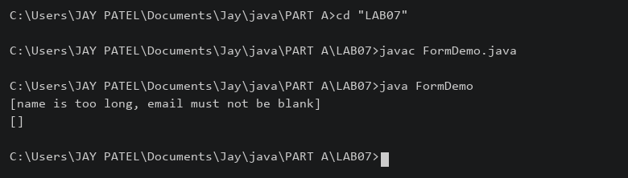

2) | Mini test runner: define a @Run annotation and mark some no-arg methods of a class  with it. Use reflection to find and invoke only the @Run methods and report how many  ran — the idea behind how JUnit finds @Test methods.
 | MiniRunner.java
Code | import java.lang.annotation.*;  import java.lang.reflect.*;  @Retention(RetentionPolicy.RUNTIME)  @Target(ElementType.METHOD)  @interface Run {}  class Checks {  @Run public void first() { System.out.println("First ran"); }  @Run public void second() { System.out.println("Second ran"); }  public void helper() { System.out.println("Helper"); }  }  public class MiniRunner {  public static void main(String[] args) throws Exception {  Checks checks = new Checks();  int count = 0;  for (Method m : Checks.class.getDeclaredMethods()) {  if (m.isAnnotationPresent(Run.class) && m.getParameterCount() == 0) {  m.setAccessible(true);  try { m.invoke(checks); }  catch (InvocationTargetException e) {  System.out.println("Failed: " + e.getCause().getMessage());  }  count++;  }  }  System.out.println("Methods ran: " + count);  }  }
Output | 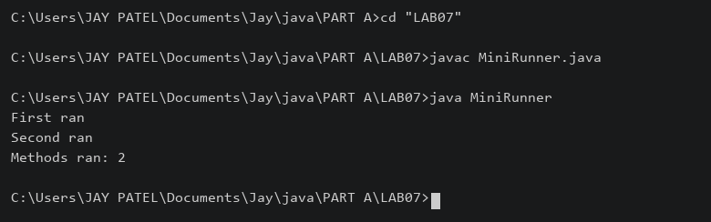

3) | (For Advanced Learners – home) Define a @Column(name) annotation and, by  reflection, populate an object’s fields from a header row and a data row by matching  column names; decide how to handle a missing column.
 | ColumnDemo.java
Code | import java.lang.annotation.*;  import java.lang.reflect.Field;  @Retention(RetentionPolicy.RUNTIME)  @Target(ElementType.FIELD)  @interface Column { String name(); }  class Student {  @Column(name="name") String name;  @Column(name="age") int age;  @Column(name="city") String city;  }  public class ColumnDemo {  static void populate(Object obj, String[] headers, String[] row) throws Exception {  for (Field f : obj.getClass().getDeclaredFields()) {  Column column = f.getAnnotation(Column.class);  if (column == null) { continue; }  int index = -1;  for (int i = 0; i < headers.length; i++) {  if (headers[i].equals(column.name())) { index = i; break; }  }  if (index < 0 || index >= row.length) {  System.out.println("Missing column: " + column.name()); continue;  }  f.setAccessible(true);  if (f.getType() == int.class) { f.setInt(obj, Integer.parseInt(row[index])); }  else { f.set(obj, row[index]); }  }  }  public static void main(String[] args) throws Exception {  Student s = new Student();  populate(s, new String[]{"name", "age"}, new String[]{"Tej", "19"});  System.out.println(s.name + " " + s.age + " " + s.city);  }  }
 | A missing column is reported and the field keeps its default value.
Output | 

